How to obtain an Esri Projection File for use in Trimble’s Pathfinder Office
In order for an Esri shapefile to show up in the correct geographical location a projection file is required. Trimble's Pathfinder Office shapefile export has an option for you to browse to an existing projection file so that one will be created for your exported shapefiles. You don't have to include this on export, but you will receive a warning whenever you try to export. Some customers may not have projection files available to them if the ArcGIS software isn't installed.
There are a few options for creating an Esri projection file to use with shapefiles exported from Trimble Pathfinder Office.
- Manually create the projection file.
- Download or use an existing Esri Projection Files
- Set the projection manually in ArcCatalog
- Install the Save Coordinate System File Add-in for Esri

Option 1 Workflow: Manually create the projection file.
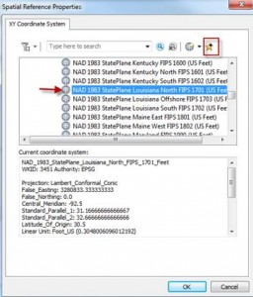
If you are running ArcGIS 10.1 or higher then do the following:
- Open ArcCatalog
- Create a new shapefile
- Under Spatial Reference, select edit
- Set the coordinate system/datum you need
- Add it to your favorites (see picture to right)
- Repeat for all coordinate systems you need

- Browse to: On Win7, the Favorites location is something like:
c:\Users\[login]\[Roaming | Local | etc]\AppData\ESRI\Desktop10.1\ArcMap\Coordinate Systems
Example C:\Users\eric_bock\AppData\Roaming\ESRI\Desktop10.1\ArcMap\Coordinate Systems
On WinXP, it's C:\Documents and Settings\[login]\Application Data\ESRI\Desktop10.1\ArcMap\Coordinate Systems
NOTE * You may have to unhide your folders so you can see AppData folder
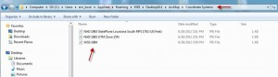

Option 2 Workflow: Download or use an existing Esri Projection File
- NEI has provided its customers Esri Projection files for its territory. Click here for some common Esri Projection files.

Option 3 Workflow: Set the projection manually in ArcCatalog
  - Open ArcCatalog
  - Browse to your shapefile
  - Right click on the shapefile and select properties
  - Choose the XY Coordinate System tab
  - Browse to the projection file that matches your Pathfinder Office Export Settings

Option 4: IInstall the Projection File Extractor Add-in
- Download the SaveCoordinateSystemFileAddIn.zip file from here.
- Download Support note from here.

