- Go into an official AT&T store and ask for a ‘Standard Size’ SIM card. This is FREE.
  - Request to activate this SIM card for use…this will assign a phone number to the card.
    - When activating AT&T will need to record your name and address.

- Next ask to purchase a prepaid ‘Go Phone’ plan for the newly activated card.
  - The initial setup requires either the $40 or $60 plans shown below for compatibility:
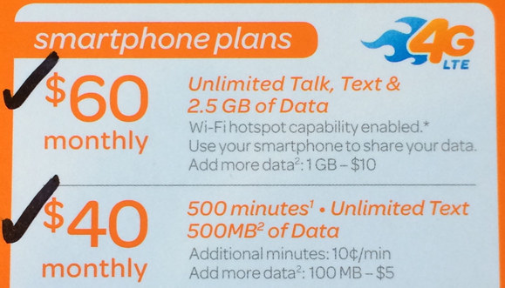
  - The $60 plan is recommended, it includes 2.5 GB of data and can refilled for as little as $10 for 1GB as necessary.
  - As data is depleted user should receive text notifications of the remaining balance.
  - To refill users can use the in-store kiosk or visit http://www.att.com/mygophone or call 800.901.9878.

- With the Geo turned off insert the SIM card into its slot.
- Turn on the Geo
  - Go to Wireless Manager and ensure the ‘Phone’ is turned on.
  - Go to Setting> Connections> Connections.
  - Select ‘Automatically configure connection’ (see below):
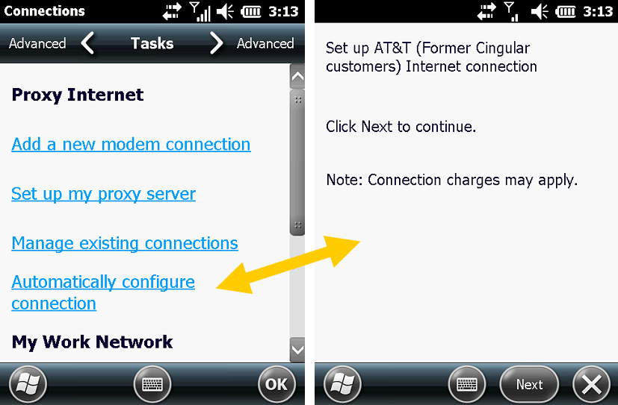
  - Next message displayed should indicate the setup was successful.

- To test the internet connection, go to ‘Internet Explorer’ and enter neigps.com.
  - When the site loads your internet connection will be successfully complete and setup.

